**EventApp Acadguild Project**

**Synopsis**

**The project is designed to get Restaurant details of local area and also by search Left side the user can see Googgle map blips of restaurant location with details when clicked and on left side list of restaurants of that area with details like open or closed, rating and address**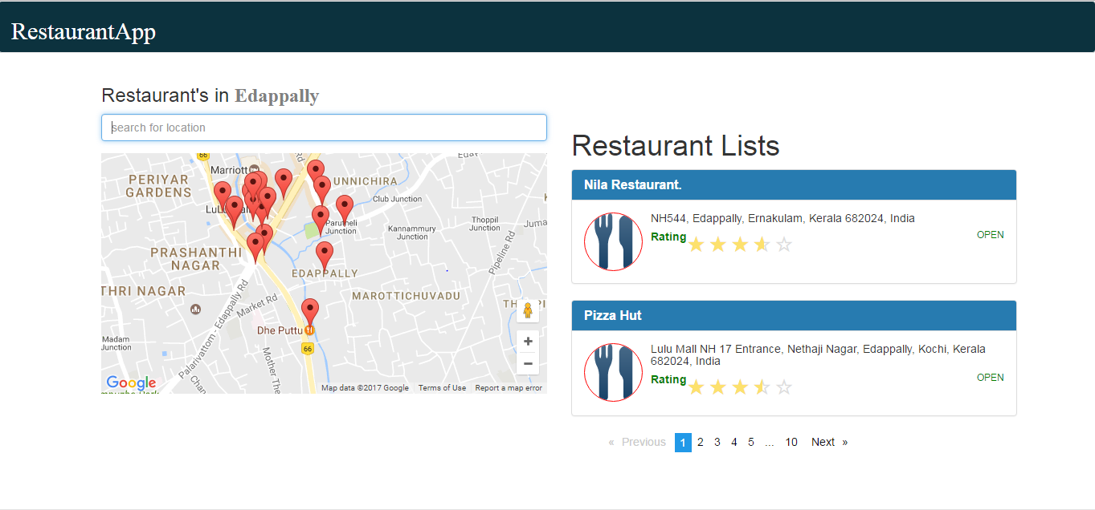

**Tools used**

* Have used angular2 cli to start project
* Have used angular2-google-maps for google map display.
* Have used ng2-rating for display rating.
* Have used ng2-pagination for pagination implementation of restaurant lists.

**Mobile View**

